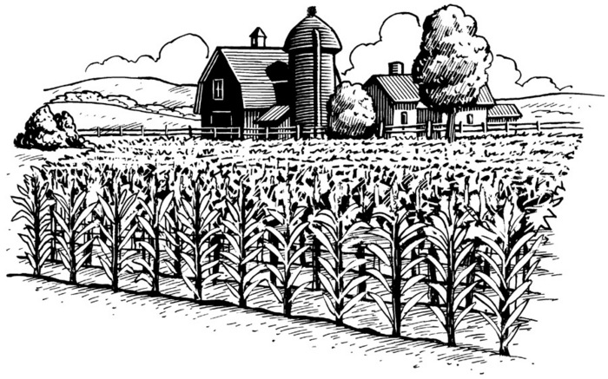
Arran Tara Agricultural Society
℅ Amanda Hammell
335 Concession 2, Dobbinton
N0H 1L0
Phone: 519-934-2357
arrantaraagsociety@gmail.com

EXIHIBIT SPACE CONTRACT 2022

Please complete the below information if you are interested in participating at our annual Fall Fair September 13th-14th, 2022

Please indicate footage and return this signed contract with payment by September 4th, 2022 to guarantee the space you request. Height of Machinery for Arena door must not exceed 10 ft. Please place cardboard /paper under Machinery Tires.

There will be 2 complimentary passes per exhibit space. Please come to the secretary’s office to collect your passes when setting up.

If you require tables for your booth, the cost is $5.00 per table. Please indicate how many you require and attach cost with your form.

Set-up Time: Tuesday 9am – 5pm
Doors open to public: Tuesday 6:30pm – 9pm
Wednesday 9am – 5pm

10 ft - $40.00 25 ft. - $75.00

15 ft - $55.00 30 ft - $90.00

20 ft - $70.00 40 ft - $120.00

Tables @ $5.00 each _______

Contact Information

Name/Company: _________________________________________________

Email: _________________________________________________________

Telephone: ____________________________

Product of Booth _________________________________________________


On behalf of the Arran-Tara Agricultural Society we thank you for your participation. Sincerely Amanda Hammell

